***PAAREES PERFUMES***

***THIERRY MUGLER***

***FOR UNISEX***

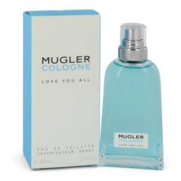

# 

# MUGLER LOVE YOU ALL

## *Description:*

Mugler Love You All by Thierry Mugler Perfume. The light, refreshing fragrance of Mugler Love You All perfume makes in perfect for everyday wear. A tantalizing blend of sweet gourmand and balsamic accords, this delicate perfume was launched in 2018 in collaboration with Jean-Christophe Herault. The aroma opens with a sweet note of blue licorice, which incorporates the gourmand accord while adding a subtle undertone of fresh spiciness. A base note of amber grounds the perfume with an earthy, aromatic undertone. Designed with only two ingredients, this fragrance is refreshingly light and simple. Spritz it on before running errands to enjoy the delicate, feminine scent all day without becoming overwhelmed by the aroma.